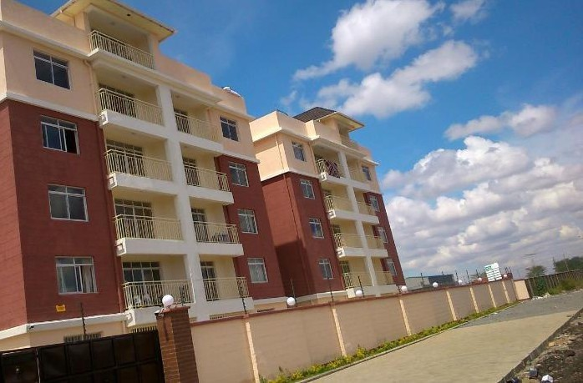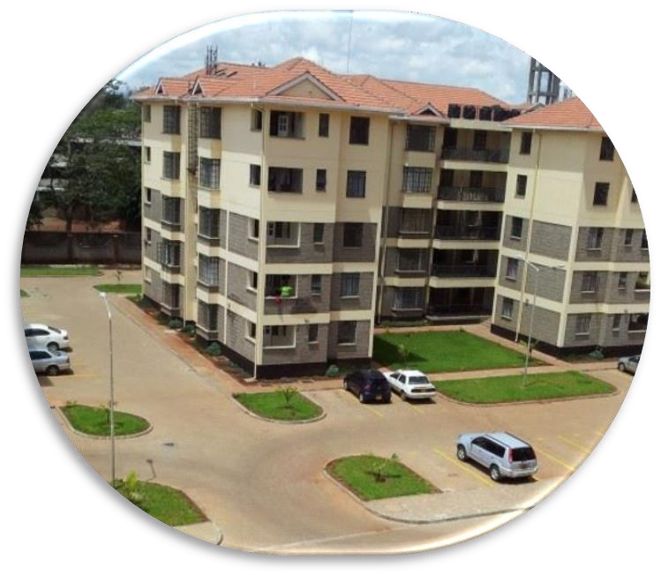

*Registered EstateAgents*



**PROPERTY MANAGEMENT PROFILE. REGISTERED REAL ESTATE AGENTS POST OFFICE BOX: 11993 – 00100, NAIROBI**

**OFFICES IN: RUAKA SUITE C3 2ND FLOOR UPENDO HOUSE**

**(KARIUKI DRIVE).**

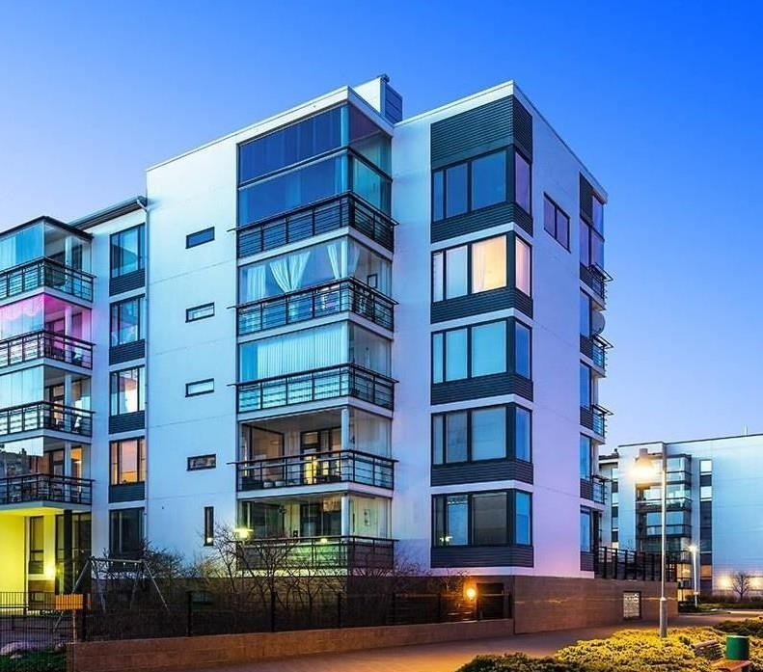

To achieve the highest possible standards of the real estate market while establishing our agency as the premier and preferred real estate company in Ruaka and surrounding areas within Kenya, Africa and World.

To be only TRUE Real Estate Company that provides an excellent and consistent customer experience 100% of the time.

# QUALITY:

Courtland Realtors Limited promises professional and exceptional services.

Our Property Management cores values are based on following pillars:

We deliver only excellence and aim to exceed expectations in everything we do.

# INTEGRITY:

We conduct ourselves in the highest ethical standards, demonstrating honesty and fairness in every decision and action.

# ABILITY:

We execute expeditiously to address our clients’ needs.

# COURAGE:

We make decisions and act in the best interests of our clients, even in the face of personal or professional adversity.

# RESPECT AND TRUST:

We treat our clients and each other with dignity and respect at all times.

**FUN:** We believe in having fun at work and with each other.

**PROPERTY MANAGEMENT**

**PROPERTY SALES PROPERTY INVESTMENT**

**CONSULTANCY**

**PLOTS AND SALES**

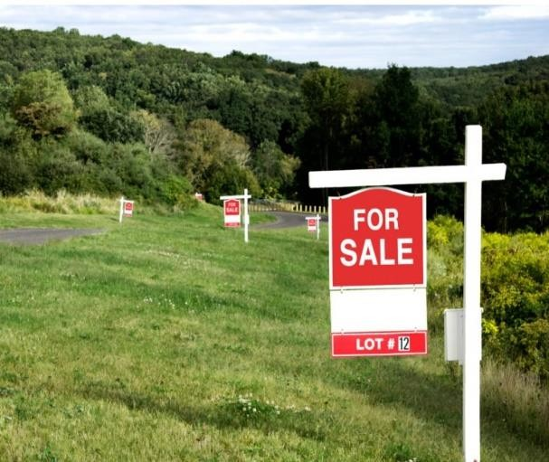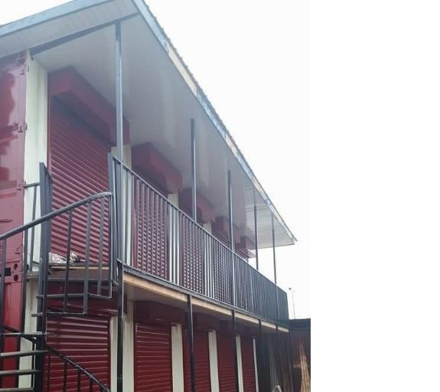

**PROPERTY SCOUTING AND LETTING**

**BUSINESS SPACE LEASING CONSULTANCY**

**PROPERTY SALES AND LETTING.**

Our online property portal provides the largest property database in Kenya and Ruaka at large, with an extensive range of commercial and residential property listings, attracting a large number of daily online visitors. We employ a very professional dynamic sales team with extensive knowledge of the local market supported by aggressive and Innovative Marketing Solutions including the following: E‐Marketing, Social Media Networks, MS Marketing,

Periodical Newsletters, Brochures, Exhibitions, Signage’s and Property Virtual Tours &Walkthroughs Giving a property the exposure it deserves to find quality tenants or to sell for the right price requires enormous

commitment. At Courtland realtors limited, we give our clients access to substantial marketing and to our pool of high-quality tenants and buyers thus reducing the turnover time for properties and achieving a better price. In the marketing stage, our work involves creative design of marketing material, on-site marketing through signboards, hosting of open days, print marketing, web marketing and property viewings. At the transaction stage, we follow through on all legal paperwork and payments to ensure the deal is brought to a close.

At all stages, we will review and advise owners of the best ways in which to enhance values of their properties, whilst at the same time, aligning price expectations to market levels. This ensures we are able to offer buyers and tenants a hand-picked portfolio of properties that offer good investment and rental opportunities.

**PROPERTY/ASSET MANAGEMENT**

Courtland realtors Limited has a department in professional property management which is tailor made and fine tune to handle each and every inquiry we get on property and asset management. We charge/levy a 5% commission of the total rent collected per month on every project acquired.

* The major functions include:
* Collecting and depositing rent payments on timely basis.
* Following up with arrears.
* Reviewing the financial statements with the bookkeeper and the owner of the property
* Responding to tenant requests for repairs and maintenance with the consultation of the property

owner.

* Paying routine bills like water, electricity, fuel and property tax on behalf of the landlord.
* Keeping up with government paperwork requirements, which can include going over tax returns with the accountant
* Dealing with government agencies like rent tribunals and advising Landlords on the same. Receiving

tenant complaints about other tenants and fixing them promptly.

* Planning on going capital repairs, e.g. elevator replacement every couple of decades. That includes dealing with the buildings architect or engineer.
* Management of caretakers and service providers such as garbage collectors.
* Management of common arrears to ensure cleanness’ is adhered to all the time

**MANAGEMENT SERVICES**

Property Management entails following functions that we normally ensure they carried out in a professional manner.

* + Tenancy agreements executions by new tenants.
  + Move-in and move-out inspections
  + Negotiate lease renewals with tenants
  + Tenant screening, background and credit check
  + Property inspections
  + Routine tenant relations and correspondence
  + Preparation of management reports

**MAINTENANCE AND REPAIR**

We do liaise with the property owners to carry out services like

* + Coordination of routine maintenance and repairs
  + Unit-clean out and preparation for new tenants
  + Supervise the grounds maintenance work in areas where we are in charge of the service charge administration and collection
  + Coordination of emergency repair works
  + Develop preventive maintenance program
  + Advise the developers on current market rates and property finishing trends

**FINANCIAL REPORTING AND PAYEMENTS VERIFICATIONS**

We ensure following functions are carried out clearly and certified standards;

* + Prompt and timely rent collection
  + Timely rent deposits to landlords accounts less the commission agreed
  + Service charge collection
  + Tracking and collection of fees such as management and letting
  + Payment to contractors and vendors when agreed with the landlord
  + Payment of property taxes, insurance and debts if requested by the landlord

**COORDINATING THE PROPERTY CLEANING AND SECURITY SERVICES**

We do ensure that the property we manage is always in a clean condition by supervising the caretakers on site. We liaise with garbage collectors to offer collection services at a fee agreed on between the tenants and the landlords. This is usually appreciated by the tenants and property owners

**EXAMPLES OF MANAGEMENT DEPARTMENT OPERATIONS THE LETTING PROCEDURE:**

1. Viewing: The potential tenant is accompanied to view the unit of choice before they make a decision
2. Memorandum of letting: The tenant fills the memorandum of letting form indicating his/her bio-

data

1. Lease agreement preparation: we in conjunction with our legal partners prepare a lease agreement to be filled – a copy of this can be availed to you on request
2. Signing the lease agreement: The potential tenant is guided on the best way to fill the lease agreement form after he/she has understood all the clauses clearly – it should never be done under duress. The tenant must provide an original and copy of ID/Passport, memorandum of letting and details of place of work
3. Inventory taking: this is the stage where we carry out a joint unit check up with the tenant to ensure

that the state of the house, all fixtures and fittings are in good condition

1. Payments: At this stage the tenant makes all agreed payments and deposits as stated in the lease agreement form
2. Issuing of keys: Finally the tenant is issued with the keys to occupation

# RENT AND SERVICE CHARGE COLLECTION PROCEDURE:

* Rent deposit: We advise all tenants to deposit their monthly rents directly to the respective accounts and pay all utility bills to the service providers, after this the respective bank slips and receipt copies to be forwarded to our offices for authentication and filling
* Dead line of rent payment: all rent collections should be done by 5th day of every month, failure to which we send;

1. First reminder – all those who have not paid by the deadline are issued with a seven day notice to pay the rent arrears
2. Final notice – those who will not have paid the arrears after the first reminder will be issued 3

days final notice

1. Legal notice – incase a tenant fails to honor the final notice, he/she is issued with 24 hours legal notice which is based on the final notice and the tenant payment statement

Auctioneers notification: Failure to honor the legal notice, the auctioneers are notified to issue a 14 days

auction notice

Break-in order: The auctioneers obtain the break-in order to allow them to enter in the tenant unit

# REPAIR AND MAINTENANCE PROCEDURE:

Reporting: Repair and maintenance requests are reported to the management department Recording of requests: All the requests are recorded in a repairs and maintenance form

Repairs and maintenance approval: The repairs and maintenance form MUST be approved by the property

manager and the C.E.O in conjunction with the property owner

Execution of repairs: Once the approval is done by all the parties, the required materials are purchased and repairs carried out

**UNIT INSPECTION PROCEDURE:**

This must be done by a representative from the office and a technical expert with the expertise required at the time of unit exit and entrance

**DOCUMENTS USED FOR MANAGEMENT**

**HOUSE LETTING DOCUMENTS**

* + Tenancy agreement
  + Memorandum of letting
  + Inspection inventory form
  + Bio data templates.

**MANAGEMENT CONTRACTING DOCUMENTS**

* + Property details form
  + Service agreement form
  + Management proposal
  + National I.D/Passport copies

**TENANCY CLEARANCE DOCUMENTS**

* Tenancy termination letter (a one month written notice from the exiting tenant)
* Inspection inventory form
* Clearance form

**RENT COLLECTION DOCUMENTS**

* + Polite reminder
  + Final reminder
  + Legal notice
  + Tenancy termination letter

**RENT DEPOSIT REFUND DOCUMENTS**

* The rent payment/clearance statement
* Utility bills clearance statements
* Exit inventory clearance statement (repairs clearance)
* Deposit payment receipt return and copy of ID from the exiting tenant as per the tenancy agreement

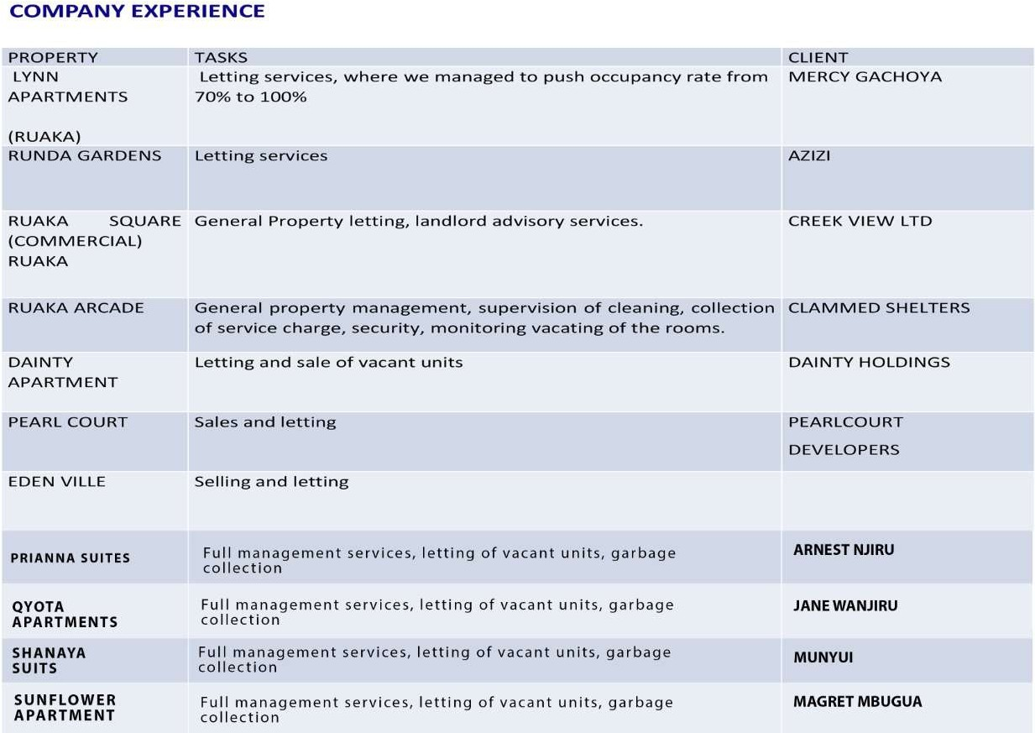

RUAKA VALLEY APART Letting Services THUMBI

COUNTY HOMES APRT Letting Services COUNTY HOMES DEVELOPERS

MONICA APARTMENT Full Management MONICA

**LETTING/MANAGEMENT COMMISSION AND PROPERTY RENT ESTIMATES**

**Letting Estimates (Ruaka Town) Executive Apartments**

|  |  |  |
| --- | --- | --- |
| NO OF BEDROOMS | DETAILS | RENT RANGE (per month) |
| 1 bedrooms | Self contained with a closed kitchen/parking  Self contained with open plan kitchen/parking | − Ksh 20,000 – 25,000   Ksh 15,000 – 20,000 |
| 2 bedrooms | Master en-suite with parking  Non en-suite/double cloak rooms/parking | − Ksh 35,000 – 40,000   Ksh 30,000 – 35,000 |
| 3 bedrooms | All en-suite/parking  Only master en-suite/parking  Open plan kitchen/master en-suite/parking | − Ksh 45,000 – 50,000   Ksh 40,000 – 45,000   Ksh 45,000 – 50,000 |

## Management/Letting commission estimates

|  |  |  |
| --- | --- | --- |
| NO | ITEM | COMMISSION ESTIMATES |
| 1 | LETTING COMMISSION | We charge a 10/25/50/100 % of the first month’s rent only |
| 2 | MANAGEMENT COMMISSION | We charge between 5 to 10% of the total rent collected on a monthly  basis. |

**Management/Letting commission estimates**

|  |  |  |
| --- | --- | --- |
| NO | ITEM | COMMISSION ESTIMATES |
| 1 | LETTING COMMISSION | We charge a 10/25/50/100 % of the first month’s rent only |
| 2 | MANAGEMENT COMMISSION | We charge between 5 to 10% of the total rent collected on a monthly  basis. |

***N/B:*** We do not charge additional charges for regular evictions; however additional legal fees, court charges and expenses will apply provided the landlord (lady) is notified before. Our commissions are also negotiable

## SOME OF OUR CLIENTELE/PROPERTIES INCLUDE

* Kencom sacco-Azizi
* Capital heights-Ruaka
* Ruaka valley apartments – Ruaka
* Runda view apartments - Ruaka
* Ruaka arcade- Ruaka
* Creek View Developers - Parklands
* Two rivers mall– Ruaka
* Ruaka Square – Ruaka
* Dainty apartment-Thindigwa
* Ruaka Landmark Plaza – Ruaka
* Pearl court Apartments – Ruaka
* Morning star apartments –Ruaka
* Centric court apartments –Kiambu road
* Lynn apartments-Ruaka

We at Courtland realtors Limited would like to assure you of quality and honesty services that are based on our strength of trustworthy and professionalism.

We look forward to working for you

For more inquiries on Courtland Property Management services and operations, you can always book an appointment with our team of Marketers, the Director or any official to have a one on one clarification on the services offered

***“We will be honored to have you as our business partner”***

